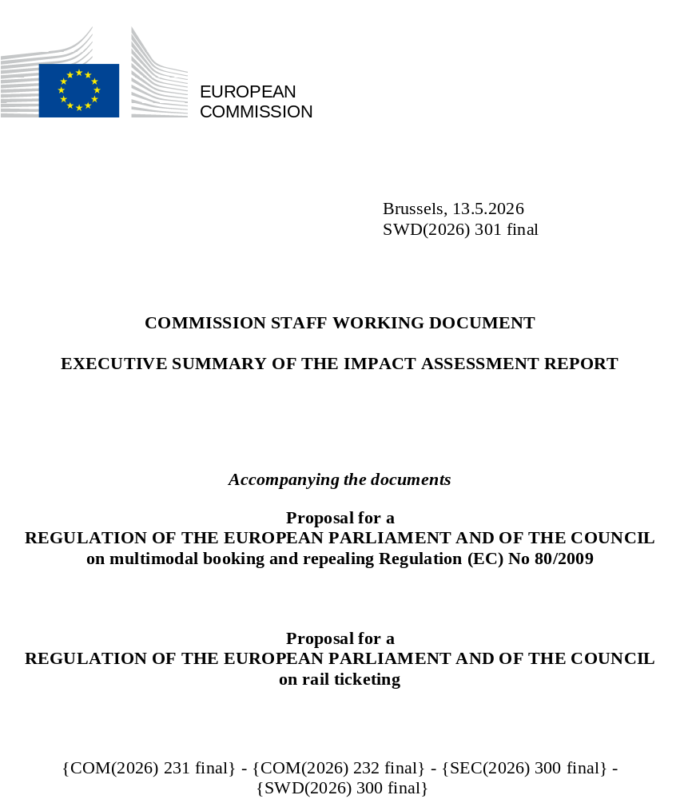

A. Need for action
What is the problem and why is it a problem at EU level?
These initiatives aim to respond to the challenges identified in the political guidelines for the European Commission 2024−2029 and address i) the lack of transparency, unfair conditions and uneven playing field in the online ticketing market, on all Multimodal Digital Mobility Services (MDMS) platforms active in aviation, rail, road and waterborne, and ii) an incomplete offer of rail tickets on MDMS platforms.
Both problems limit consumers’ ability to find, compare, combine and book travel options, while considering the environmental impact of their choices. The second problem creates barriers to market entry for smaller railway undertakings, hinders competition, reduces demand and leads to suboptimal return on public investment in rail. These initiatives will not only foster the creation of new travel options but also make sure travellers find existing options: an analysis of 100 routes in the EU showcases that in 76% of cases multimodal options exist, yet very few MDMS platforms show options in different modes, and these are rarely combined. A Eurobarometer survey from 2024 confirmed this is needed as among 26,000 EU citizens a third never booked a multimodal or multi-operator journey. The survey also showed that over a third of those who book such journeys experience booking barriers, including that they couldn’t find a suitable combination or buy all the tickets they needed in one place, and that in rail those barriers are greater.
Another concern for rail passengers is that they rarely enjoy passenger rights when their journey involves different operators. The passenger rights dimension falls outside the scope of this impact assessment and is addressed through a targeted revision of the Rail Passenger Rights Regulation, which will ensure that rail tickets purchased in a single transaction on one platform, so-called single tickets, are granted full passenger rights for the entire journey.
What should be achieved?
The general objectives are i) to promote single tickets in rail in support of modal shift, and ii) improve the functioning of the online ticket distribution market, and in doing so contribute to the competitiveness of the transport services market. These initiatives will contribute to these general objectives by pursuing two specific objectives: (1) improve the completeness of the rail ticket offer on MDMS platforms; (2) improve transparency and establish a level playing field for transport operators in terms of access and use of indispensable MDMS. These objectives are also aligned with the Smart and Sustainable Mobility Strategy goals to improve the competitiveness of the transport sector and make multimodal mobility a reality.
What is the value added of action at the EU level (subsidiarity)?
While Multimodal Digital Mobility Services can be developed at regional or national level, the identified problems are present across the EU, and an EU-wide approach to deal with them would avoid a fragmented market with increased costs and reduced benefits. The European rail ticketing market is particularly fragmented as most incumbent railway undertakings concentrate on their national operational monopolies rather than proposing well-connected rail services across Member States.
B. Solutions
What are the various options to achieve the objectives? Is there a preferred option or not? If not, why?
Four policy options have been designed to address the problems and achieve the objectives, although with a different level of effectiveness and efficiency. PO1 takes a light touch approach that ensures data is processed fairly and transport offers are displayed neutrally on MDMS platforms. It also imposes conditions for contractual distribution agreements on indispensable MDMS platforms and indispensable railway undertakings. PO2 adds to PO1 an obligation for indispensable railway undertakings to enable the distribution of their tickets on MDMS platforms. PO3 adds to PO2 an obligation on indispensable railway undertakings to distribute the tickets of competitors. PO4 presents an alternative to PO3 by obliging indispensable railway undertakings platforms to unbundle their operational and ticket distribution services, which comes with higher costs.
All policy options demonstrate coherence and respect the subsidiarity principle. With respect to proportionality, PO3 achieves best the objectives, while maintaining a lower level of market intervention compared to PO4. PO3 is the preferred policy option as it is most effective at fostering complete rail offers, also on indispensable railway undertakings platforms, and supporting a faster shift towards more sustainable travel options. It presents net benefits and is the most efficient option.
What are different stakeholders’ views? Who supports which option?
Most stakeholders recognized the need for PO1. MDMS platforms were more sceptical than other stakeholder groups, warning that rules on neutral display may hinder innovation. Railway undertakings believed that distribution fee levels should not be regulated. Stakeholders appeared more divided on PO2, with consumer organisations, national authorities and NGOs being supportive, MDMS platforms being rather positive or neutral, and indispensable railway undertakings opposing it, underlining that mutual commercial interest must guide collaboration rather than mandated access. Most national authorities, consumer organizations and NGOs supported PO3, while MDMS platforms were mostly neutral or opposing this option, and most transport operators opposed it. Indispensable railway undertakings and independent MDMS platforms raised the risk of increased market concentration of railway undertakings. Conversely, new entrant railway undertakings supported the targeted intervention and perceived PO3 as the key enabler to “double modal shift of rail for long-distance travel”. PO4 divided stakeholders, opposing the views of new entrant and indispensable railway undertakings, the former perceiving it as a “game changer” for new entrant’s accessibility to key rail platforms and visibility towards consumers, and the latter outlining the organisational complexity of unbundling and the necessary link between ticket revenues and sustaining rail operations.
C. Impacts of the preferred options
What are the benefits of the preferred option (if any, otherwise main ones)?
MDMS platforms and transport operators will benefit from cost savings due to streamlined negotiation processes, estimated for each at EUR 134 million expressed as present value over 2028-2050 relative to the baseline. Society at large will benefit from external costs savings (i.e., related to reductions of CO₂ and air pollutant emissions, noise emissions, fatalities and injuries, and congestion) estimated at EUR 37.6 billion expressed as present value over 2028-2050 relative to the baseline. The net benefits of PO3 are estimated at EUR 37.3 billion. The rail transport market will benefit from increased competition, leading to an increased offer, reduced prices and increased passenger numbers, and more innovation. This helps attracting passengers who will also spend less time looking for suitable travel options. PO3 is aligned with the 'digital by default' principle and with the environmental objectives of the European Green Deal and the European Climate Law.
What are the costs of the preferred option (if any, otherwise main ones)?
Total costs of PO3 are estimated at EUR 306 million, expressed as present value over 2028-2050 relative to the baseline. Of this, 40% are one-off and recurrent adjustment costs for MDMS platforms that will need to adjust IT systems to comply with neutral display requirements, set up application programming interfaces to share non-personal data with transport operators and public authorities (EUR 122.3 million). Adjustment costs for railway undertakings to enable the distribution of their tickets represent another 14% of the total costs (EUR 42.2 million). The enforcement costs for national authorities are estimated at EUR 106.5 million (35% of the total costs) and the administrative costs for settling disputes and for processing notifications from platforms with Significant Market Presence at EUR 28.9 million (9% of the total costs), expressed as present value over 2028-2050 relative to the baseline. The costs for the European Commission to designate MDMS with Significant Market Presence at EU level represent less than 2% of the total costs (EUR 5.3 million).
What are the impacts on SMEs and competitiveness?
SMEs are out of scope of these initiatives, which do not pose obligations on them, however PO3 is expected to benefit them and have a positive impact on their competitiveness and generate cost savings. SME MDMS platforms benefit from a level playing field for all players (EUR 90.5 million) and SME operators in all modes from access to key platforms (EUR 96.1 million).
Will there be significant impacts on national budgets and administrations?
Total additional (one-off and recurrent) administrative burden for national authorities is estimated at EUR 1.86 million per year, driven by the requirement to process notifications from platforms with Significant Market Presence and to submit this information to the Commission, and for settling disputes. In addition, enforcement costs to monitor the correct implementation of the legislation are estimated at EUR 6.1 million per year.
Proportionality
PO3 is considered proportionate as action at EU level is limited to what is necessary to address a clear market failure, achieving the EU transport policy objectives on the Single European Railway Area.
D. Follow up
When will the policy be reviewed?
Commission services will monitor the implementation of these initiatives through a set of indicators (e.g. number of operators on indispensable MDMS platforms, increased consumer satisfaction) that will measure progress towards achieving the objectives. At least five years after the implementation date, the Commission services should carry out an evaluation.

‘Europe’s choice - Political guidelines for the next European Commission 2024−2029: ‘Cross-border train travel is still too difficult for many citizens. People should be able to use open booking systems to purchase trans-European journeys with several providers, without losing their right to reimbursement or compensatory travel. To this end we will propose a Single Digital Booking and Ticketing Regulation, to ensure that Europeans can buy one single ticket on one single platform and get passengers’ rights for their whole trip’
Platforms providing traffic and travel information (e.g., schedules, tariffs and availability of services) and enabling the distribution of tickets, directly or via re-linking, for two or more transport operators, operating in one or more transport modes. This includes Computerised Reservation Systems (CRSs), currently subject to a Code of Conduct which will be repealed and replaced by including the relevant provisions in this initiative.
COM/2020/789 final
Railway undertakings that operate: 1) PSO services, 2) cross-border services, or 3) more than 50% of total rail services in a Member State.
Independent platforms benefiting from this currently hold an estimated 3% market share in rail ticket distribution

